What you should know about disordered eating
Disordered eating is a complicated phenomenon. It should be viewed as a set of behaviors and experiences rather than a specific, narrowly defined medical condition.
While there are some features that these behaviors and experiences may share, people’s individual situations can vary widely.
Eating disorders can develop from various factors, including:
- Family struggles
- Genetics
- Impaired body image
- Ineffective coping strategies
- Low self-esteem
- No feeling of personal identify
- Lack of perceived control

Physiological & psychological explanations
The exact origins of disordered eating are still unclear.
Some experts claim that genetics play a significant role in eating disorders. Those with a mother or sister who had AN are 12 times more likely than others with no family history of that disorder to develop it themselves. However, it’s not clear whether genetics is responsible, or whether the disordered eater is simply mimicking the behavior and attitudes of other family members (or both).
Others argue that eating disorders might actually be due to underlying metabolic or digestive tract disorders.
It’s been suggested that those with AN have serotonin over activity, leading to exaggerated satiety. They might also have excess activity in the brain’s dopamine receptors, leading to a drive for weight loss, but no pleasure from shedding the weight. Over-eaters may also have some disruption of dopamine, which is known to stimulate the body’s “wanting” response, or under-active satiety mechanisms.
Strict dieting and the inability to adjust to environmental stressors are two critical initiators for developing an eating disorder.
Restriction of food can cause food preoccupation, as any strict dieter can attest.
And food can become “drug-like” for those struggling to cope with stress. Some evidence links anxiety and depression with disordered eating.
Some have even suggested that disordered eating is not a “disorder” at all but simply the body’s “normal” attempt to cope with “abnormal” situations of modern stresses, cultural ideals, and food availability. In this model, disordered eating is actually a “mismatch” between Paleolithic physiology/psychology and modern lifestyle demands.

No single cause
What seems clear is that disordered eating can have many, interlocking, causes and manifestations. It’s a set of complex behaviors and experiences that can not and should not be over-simplified.
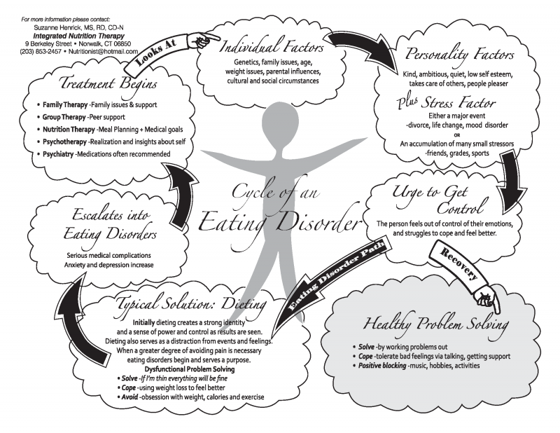

Anorexia
“Anorexia” comes from the ancient Greek orexis, or appetite. The prefix “an” denotes “without”; thus “anorexia” is literally “without appetite”.
Now we use the term to describe purposeful non-eating or avoidance of food.
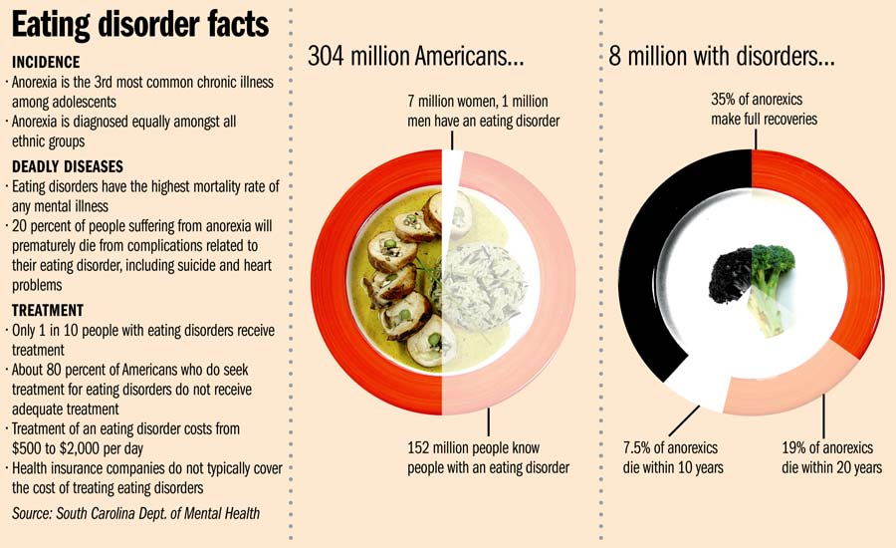

Bulimia

Characteristics
- Recurring episodes of binge eating during which the person consumes large amounts of food and feels unable to stop eating, followed by inappropriate compensatory efforts to avoid weight gain, such as self-induced vomiting, laxative or diuretic abuse, vigorous exercise, or fasting
- Using food (either overeating or purging) as a major coping mechanism
- Patients are steadily and overly apprehensive about body shape and weight
- Patients are more likely to experience loneliness, irritability, passivity, sadness, and suicidal behavior
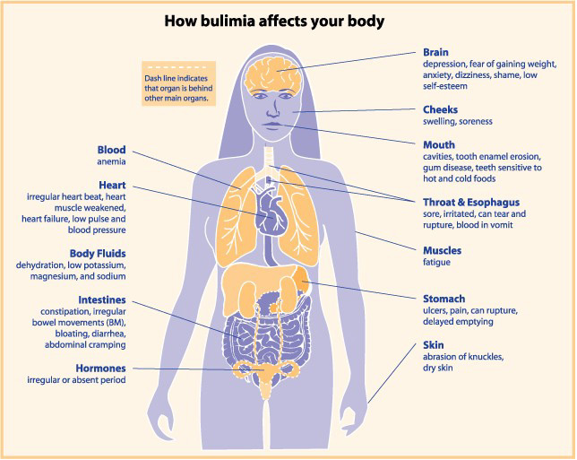

Anorexia athletica
There are two related forms of anorexia athletica. One is defined by the use of excessive exercise to maintain body weight; the other is defined by disordered eating among recreational and competitive athletes.
In both cases, exercise is usually part of a general attempt to control body size/weight, or a precipitating factor in disordered eating behaviors.

Characteristics
- When an individual no longer chooses to exercise but feels compelled to do so
- Often, exercise in excessive amounts, especially exercise that is associated with weight loss (e.g. several hours of cardio a day)
- The patient will struggle with guilt and/or anxiety if they do not exercise
- Use of excessive exercise, usually along with dietary restriction, to maintain a low body weight/fat
- Excessive exercise may follow a similar cycle as binge-purge, with exercise following a binge episode

Causes
Exercise anorexia is a compulsive behavior and many individuals do it to gain more control over their lives. It can be provoked by dieting at an early age, comments about body shape by a professional/coach and sport specific training.
Athletes engaging in team sports and sports/physical activities that emphasize either weight classes or body image (e.g. wrestling, swimming, dance) are most vulnerable, particularly if parents, coaches, or peers are focused on weight or body size.

Consequences
The health outcomes include dry hair, dry skin, hair loss, digestive difficulties, slowed heart rate, low blood pressure, dehydration, kidney problems, insomnia, joint weakness, suppressed immune function, and nutrient deficiencies.
Athletic performance is eventually also affected, as athletes may suffer recurring injuries and illnesses, cognitive impairments, and poor recovery from training.
Source: http://www.precisionnutrition.com/all-about-disordered-eating

What to do if you or someone you know is suffering from an Eating Disorder
As with other types of addictions, there’s not much anybody can do until the person with the disordered eating wants to change. Confrontation and harassing generally don’t help. Nor does well-meaning advice such as “Get over it” or “You should love your body”. One of the best things to say to someone you suspect has disordered eating patterns is:
“Let me know if there is anything I can do to help.”
Direct statements or judgments about body size or eating habits will most likely elicit resistance. If you are concerned about your own eating patterns, and suspect they are disordered, we suggest seeking out resources to assist in recovery. Strict dieting will likely create further problems. Remember, the disorder probably extends beyond food.
Find books, a counselor and/or a support group that can assist you in making a recovery. It’s tough, but it’s worth it.

